**6.2 Scale Factors Classwork**

1. 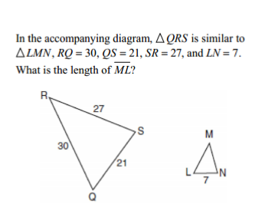

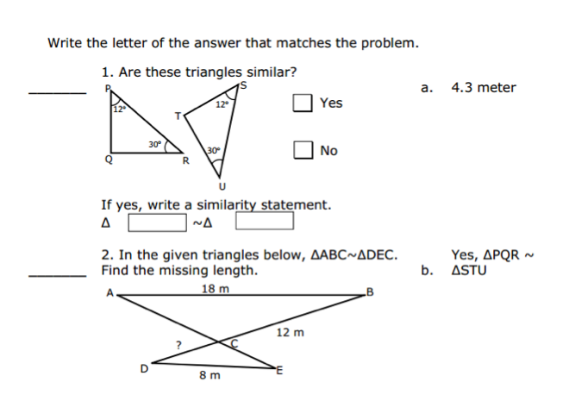

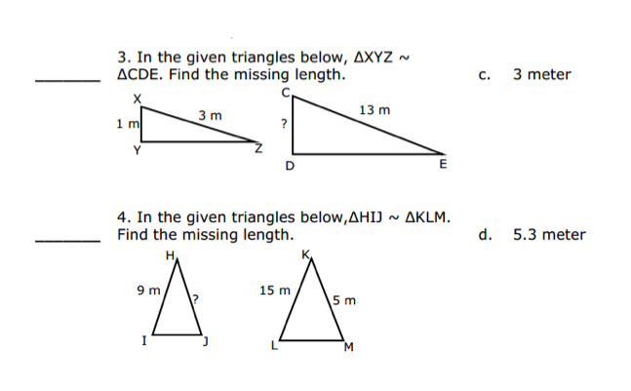



**6.2 Scale Factors Homework**

*Mild – 8/10 points for completing this section*

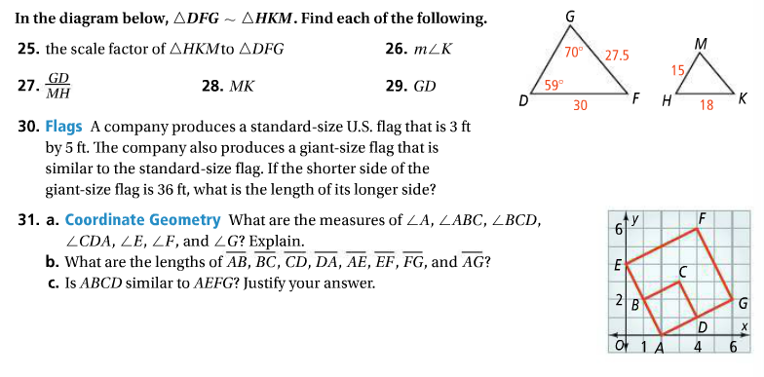



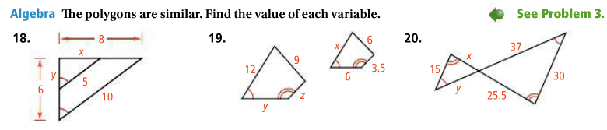







*Medium – 9/10 for completing Mild + this section*

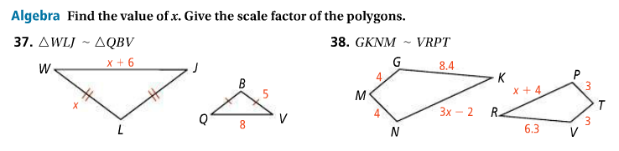





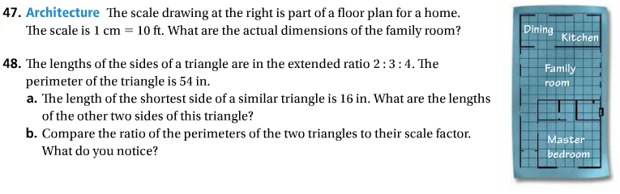



*Spicy – 10/10 for completing Mild + Medium + this section*

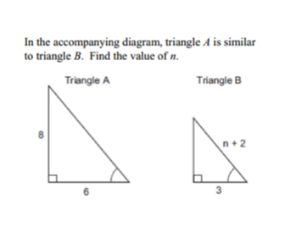





APPLICATIONS OF 6.2

